Requirements Specification
Cigna
ODI Data Model Subject Area Functional Requirements

Author: Raghav/Lakshmi Supriya
Creation Date: SEP 30, 2016
Last Updated: SEP 30, 2016
Document Ref: N/A
Version: DRAFT

Approvals:
<Approver 1> | Vinay Pachika
<Approver 2> | Christine Park

Document Control
Date | Author | Version | Change Reference
SEP 30,2016 | Raghav/Supriya | 1 | No Previous Document

Reviewers

Name | Position
Christine Park | BI Business Lead
Viswam Nair | IT Lead
Vinay Pachika | IT Lead
Chattopadhyay, Abhishek | TL

4

Contents
1 Document Control 2
1.1 Reviewers 2
2 Introduction 4
2.1 Purpose 4
2.2 Assumptions and Dependencies 4
2.3 Definitions, Acronyms, and Abbreviations 5
3 Requirements 6
3.1 Business Requirements 6
4 Design / Approach 7
4.1 Logical Data Model 7
5 Supporting Requirements 8
5.1 Overall Supplemental Requirements 8
5.2 Performance 8
5.3 Audit and Control 8
5.4 Testing 8
6 Open and Closed Issues 9
6.1 Open Issues 9
6.2 Closed Issues 9

Introduction
As part of the Building Financial Foundations project, Oracle Enterprise Business Suite (EBS) R12 was implemented / upgraded in an effort to modernize the overall accounting and financial reporting process. Reporting for the General Ledger (GL), Accounts Payable (AP), Fixed Assets (FA) and Accounts Receivable (AR) were developed in Discoverer.
To build upon the current reporting, the Expense Redesign projects plans to implement Business Intelligence (BI) to:
- Integrated systems and reporting tools to automate business processes and better insight into data resulting in time and cost savings
- Self-Service Business Intelligence to aid timely and intelligent business decisions by providing trustworthy and relevant and timely access to data
- Build a solid foundation for future reporting needs, including management reporting and analytics. Replace older reporting tools with modern and more effective integrated reporting technologies
- Provide a platform for analytical and operational reporting
- Adhoc, reporting with drilldown and dashboard capabilities
- Extend the current operational reporting capabilities
- Enhance analytical, real time, metadata reporting capabilities

Business Intelligence reporting will be standardized on the Oracle Business Intelligence Enterprise Edition (OBIEE) platform. Oracle Business Intelligence Application (OBIA) will be implemented to provide GAAP, STAT, MLR reporting, extend analysis capabilities, and provide operating expense reporting to various areas in the Finance community.

Purpose
The ODI Operator is great for technical users who have ODI installed but can be complex for business users. Operator can also become slow due to the large number of interfaces that run each night. Exposing the ODI work schema to OBIEE was a logical solution to this problem. We used OBIEE as a way to report and graph ODI ETL executions so that we can view ETL success and failures.
It is also worth noting that having good naming conventions can really help with navigating the ETL repository. For example all of our interfaces are prefixed with INF_%, and Packages with PKG_%. We also have naming conventions for loading Staging, Dimensions, and Facts, etc.

Assumptions and Dependencies

- Latency of data will directly depend on when the last data refresh (standard and custom) happened. Normal schedule of data refresh is daily / nightly.
- No analysis or dashboard will be built as part of this requirement. Only subject area structure will be available for end users to perform adhoc reporting.

Definitions, Acronyms, and Abbreviations
Acronym | Name | Description
EBS R12 | Oracle E-Business Suite Release 12 | Financials System
OBIA | Oracle Business Intelligence Applications | Oracle BI analytics pre-packaged application
OBAW / DW | OBIA Data warehouse
BI | Business Intelligence | Oracle Analytics tool

Requirements

Business Requirements
- Exposing the ODI work schema to OBIEE with a logical solution to view ETL success and failures.

Design / Approach

Logical Data Model
ODI dimensional data model with fact and standard dimensions is represented below:
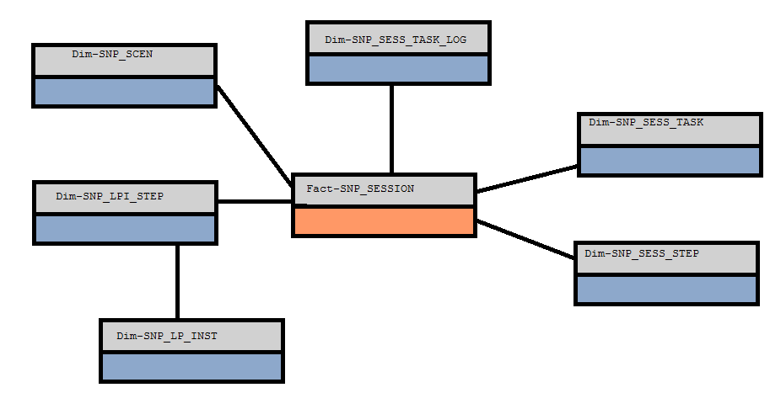

- SNP_SESSION - Stores the Session_id and detailed related to session
- SNP_SESS_STEP - All interface package, scenario and procedure details.
- SNP_STEP_LOG - This has the steps within each ODI object.
- SNP_SESS_TASK - represents the KM(Knowledge Module), details related to interface ,procedure, tools in a package with design time details .
- SNP_SESS_TASK_LOG - represents the KM, details related to interface, procedure, tools in a package with run time details (including error message)

Supporting Requirements
The supporting information makes the Requirements Specification easier to use. It includes:
- Table of Contents
- Index
- Appendices
These may include use case storyboards or user-interface prototypes. When appendices are included, the Requirements Specification should explicitly state whether or not the appendices are to be considered part of the requirements.

Overall Supplemental Requirements
The intent of this section is to record the Supplemental Requirements. Reference the Supplemental Requirements (RD.055)

The intent of this section is to record the User Interface Standards Requirements. You may include samples, and textual descriptions of the UI standards. Reference the User Interface Standards Requirements (RA.095)

Performance
The intent of this section is to record the Performance management requirements. Reference the Performance Management Requirements and Strategy (PT.020).

Audit and Control
The intent of this section is to record the Audit and Control requirements. Reference the Audit and Control Requirements and Strategy (RD.070).
The intent of this section is to record the Data Acquisition and Conversion requirements. Reference the Data Acquisition and Conversion Requirements (CV.010).
The intent of this section is to record the Documentation requirements. Reference the Documentation Requirements and Strategy (DO.010).
The intent of this section is to record the Technical Architecture requirements. Reference the Architecture Requirements and Strategy (TA.020).

Open and Closed Issues

Add open issues that you identify while writing or reviewing this document to the open issues section. As you resolve issues, move them to the closed issues section and keep the issue ID the same. Include an explanation of the resolution.
When this work product is complete, any open issues should be transferred to the project- or process-level Issue Log (Manage focus area) and managed using a project level Issue Form (Manage focus area). In addition, the open items should remain in the open issues section of this work product, but flagged in the resolution column as being transferred.

Open Issues

ID | Issue | Resolution | Responsibility | Target Date | Impact Date

Closed Issues

ID | Issue | Resolution | Responsibility | Target Date | Impact Date
.

